**Pre-Lab 10:**

**Characterization of the MOSFET**

Name: Wan-Yu Liao

ECEN 325 Section 514

TA: Mandela

Date: November 7, 2019

**Simulations**

**(1) NMOS using 2N7000G**

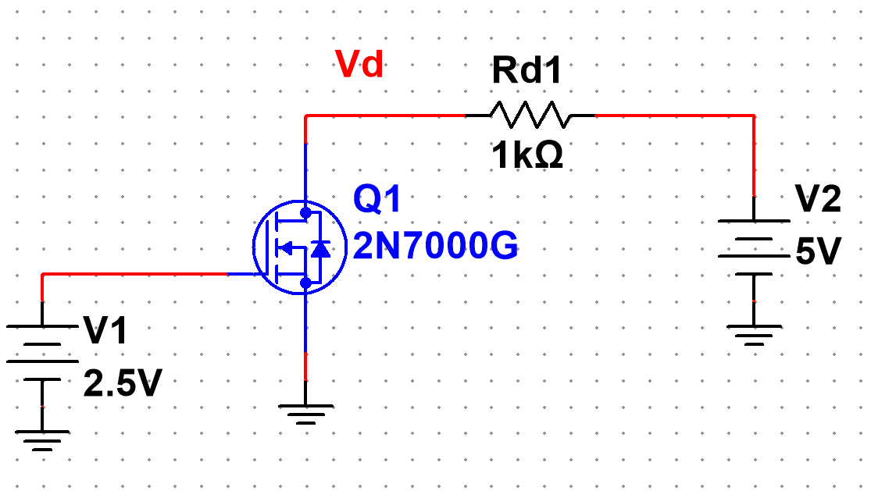

**Figure 1:** Schematic for NMOS using 2N7000G ▲

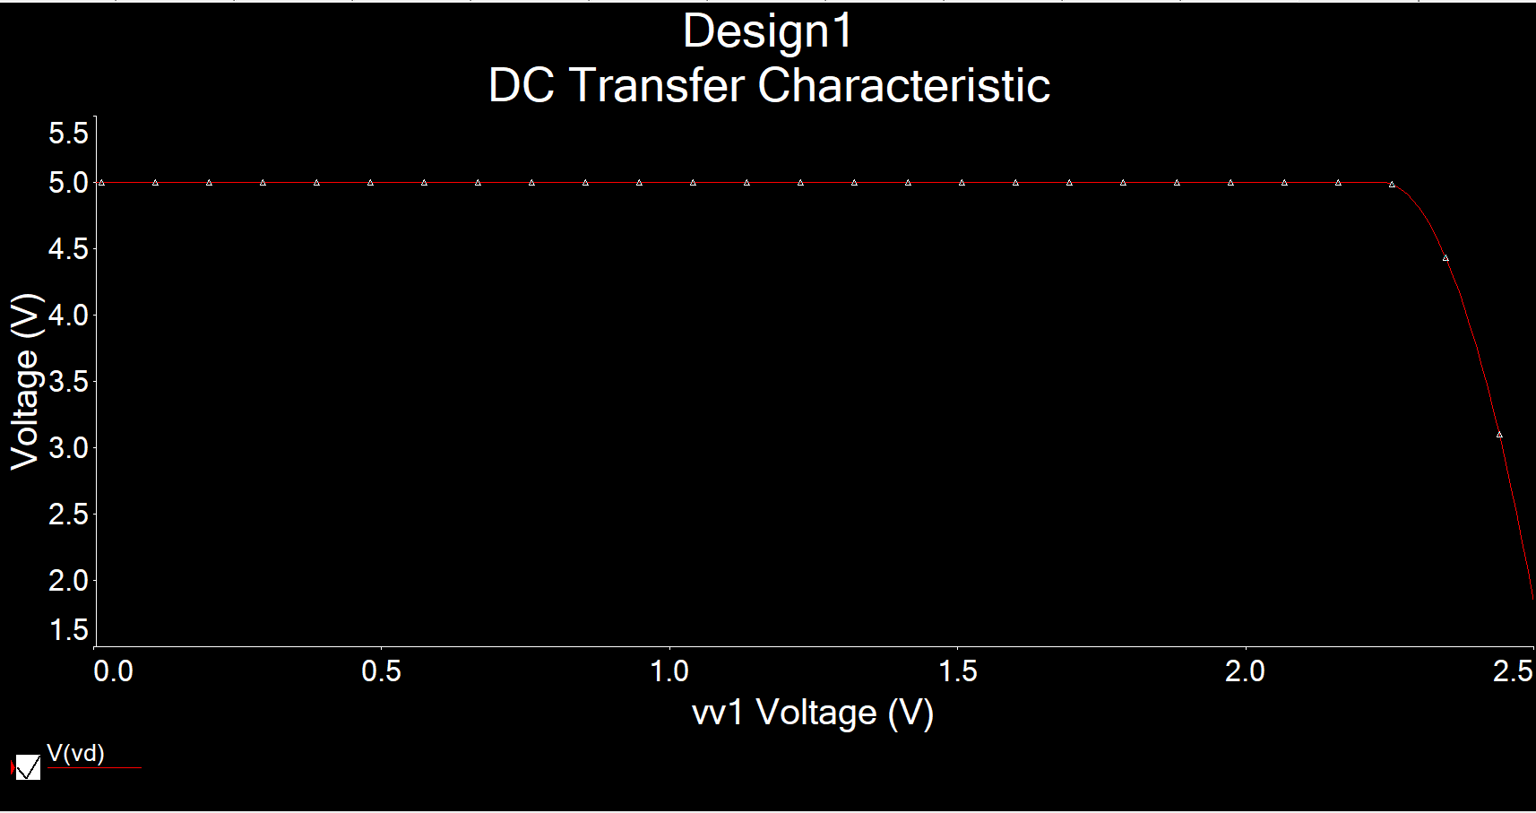

**Figure 2:** Simulation of NMOS characterization circuit using DC sweep of V1 from 0 to 2.5V,

while V2 = 5V ▲

**Figure 3:** Excel plot of NMOS characterization circuit using DC sweep of V1 from 0 to 2.5V,

while V2 = 5V, where Id = (5-Vd)/1000 ▲

**Figure 4:** Excel plot of NMOS characterization of derivative of Id’ vs. Vgs▲

Threshold Voltage Vt = **2.23V**

Transconductance parameter = (0.023218-0)/(2.5-2.23) = **0.086**

**(2) NMOS using CD4007N**

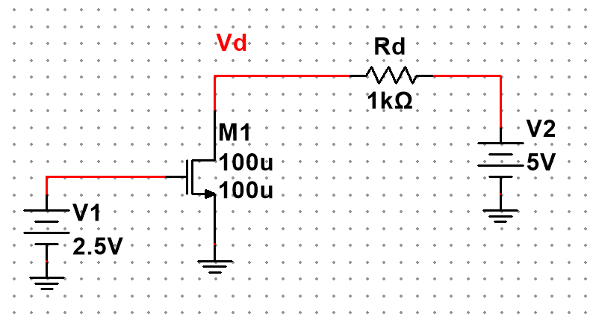

**Figure 5:** Schematic for NMOS using CD4007N (β=102mA/V2, VTN=2.0V) ▲

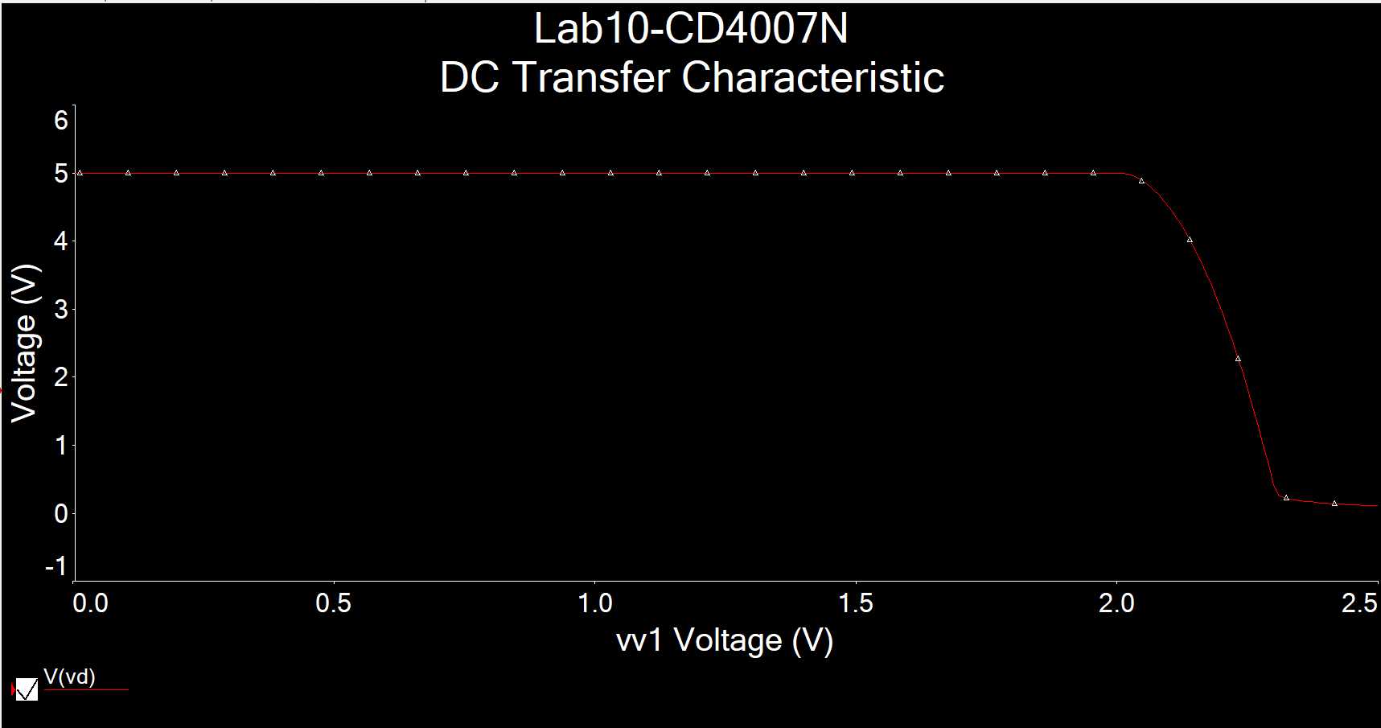

**Figure 6:** Simulation of NMOS characterization circuit using DC sweep of V1 from 0 to 2.5V,

while V2 = 5V ▲

**Figure 7:** Excel plot of NMOS characterization circuit using DC sweep of V1 from 0 to 2.5V,

while V2 = 5V, where Id = (5-Vd)/1000 ▲

**Figure 8:** Excel plot of NMOS characterization of derivative of Id’ vs. Vgs▲

Threshold Voltage Vt = **2V**

Transconductance parameter = (0.03009-0)/(2.3-2) = **0.1003**

(3) PMOS using CD4007P

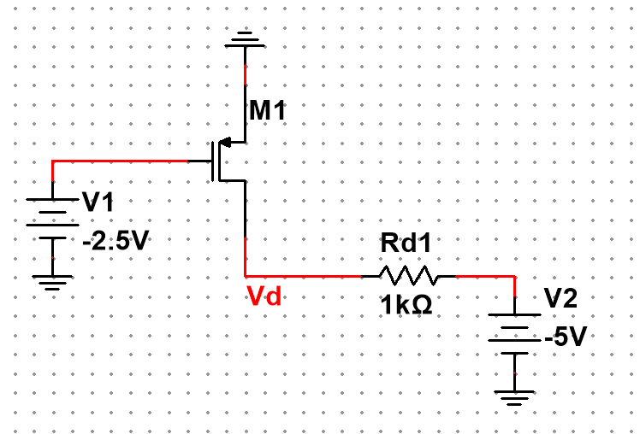

**Figure 9:** Schematic for PMOS using CD4007P (β=102mA/V2, VTN=2.0V) ▲

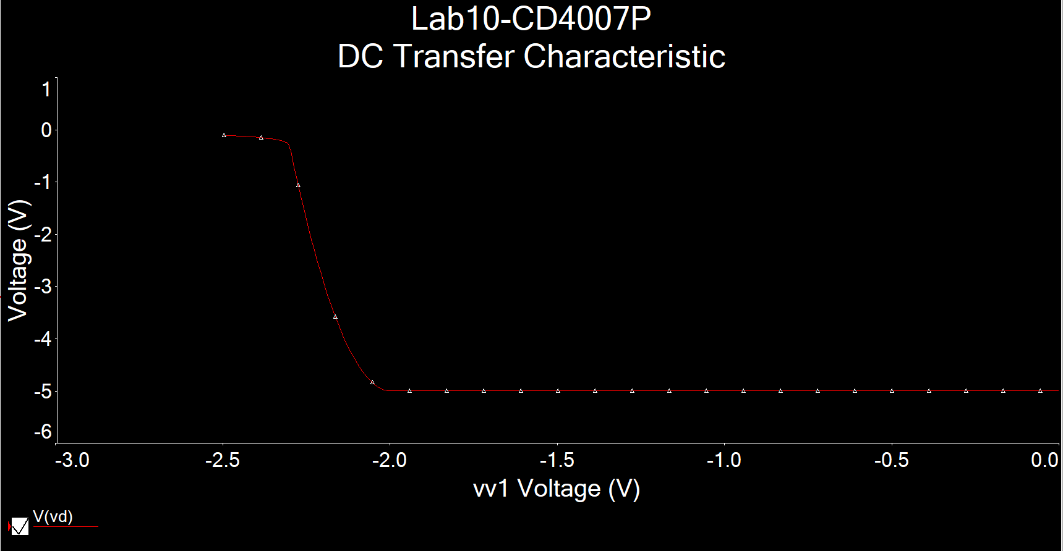

**Figure 10:** Simulation of PMOS characterization circuit using DC sweep of V1 from -2.5 to 0V,

while V2 = -5V ▲

**Figure 11:** Excel plot of PMOS characterization circuit using DC sweep of V1 from -2.5 to 0V,

while V2 = -5V, where Id = (Vd+5)/1000 ▲

**Figure 12:** Excel plot of PMOS characterization of derivative of Id’ vs. Vgs▲

Threshold Voltage Vt = **2.01V**

Transconductance parameter = (0.03009-0)/(2.3-2.01) = **0.1037**